

DMN Modeler Report
DT Using Variables

Published: 7/30/2018
By: Edson Tirelli
Table of Contents
Decision Table - compare values 3
Decision Requirement Diagram 3
Elements 3

Decision Table - compare values

Decision Requirement Diagram
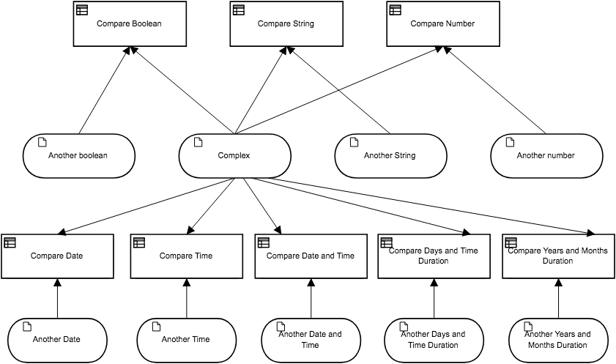

Elements
Compare Boolean (Decision)
Output Data Type
Type | Text

Decision Logic (Decision Table)
Compare Boolean
Text
 | U | Another boolean |  | Compare Boolean
 |  | Boolean |  | Text
 | 1 | Complex.aBoolean |  | "Same boolean"
 | 2 | not(Complex.aBoolean) |  | "Not same boolean"

Compare String (Decision)
Output Data Type
Type | Text

Decision Logic (Decision Table)
Compare String
Text
 | U | Another String |  | Compare String
 |  | Text |  | Text
 | 1 | Complex.aString |  | "Same String"
 | 2 | not(Complex.aString) |  | "Different String"

Compare Number (Decision)
Output Data Type
Type | Text

Decision Logic (Decision Table)
Compare Number
Text
 | U | Another number |  | Compare Number
 |  | Number |  | Text
 | 1 | Complex.aNumber |  | "Equals"
 | 2 | >Complex.aNumber |  | "Bigger"
 | 3 | < Complex.aNumber |  | "Smaller"

Another boolean (Input Data)
Input Data Type
Type | Boolean

Complex (Input Data)
Input Data Type
Type | Complex

Another String (Input Data)
Input Data Type
Type | Text

Another number (Input Data)
Input Data Type
Type | Number

Compare Date (Decision)
Output Data Type
Type | Text

Decision Logic (Decision Table)
Compare Date
Text
 | U | Another Date |  | Compare Date | Description
 |  | Date |  | Text
 | 1 | Complex.aDate |  | "Same Date"
 | 2 | > Complex.aDate |  | "Future Date"
 | 3 | < Complex.aDate |  | "Past Date"

Compare Time (Decision)
Output Data Type
Type | Text

Decision Logic (Decision Table)
Compare Time
Text
 | U | Another Time |  | Compare Time | Description
 |  | Time |  | Text
 | 1 | Complex.aTime |  | "Same Time"
 | 2 | > Complex.aTime |  | "Future Time"
 | 3 | < Complex.aTime |  | "Past Time"

Compare Date and Time (Decision)
Output Data Type
Type | Text

Decision Logic (Decision Table)
Compare Date and Time
Text
 | U | Another Date and Time |  | Compare Date and Time | Description
 |  | Date and time |  | Text
 | 1 | Complex.aDateTime |  | "Same date time"
 | 2 | > Complex.aDateTime |  | "Future date time"
 | 3 | < Complex.aDateTime |  | "Past date time"

Compare Days and Time Duration (Decision)
Output Data Type
Type | Text

Decision Logic (Decision Table)
Compare Days and Time Duration
Text
 | U | Another Days and Time Duration |  | Compare Days and Time Duration | Description
 |  | Days and time duration |  | Text
 | 1 | Complex.aDaysAndTimeDuration |  | "Same duration"
 | 2 | > Complex.aDaysAndTimeDuration |  | "Longer duration"
 | 3 | < Complex.aDaysAndTimeDuration |  | "Shorter duration"

Compare Years and Months Duration (Decision)
Output Data Type
Type | Text

Decision Logic (Decision Table)
Compare Years and Months Duration
Text
 | U | Another Years and Months Duration |  | Compare Years and Months Duration | Description
 |  | Years and month duration |  | Text
 | 1 | Complex.aYearsAndMonthsDuration |  | "Same duration"
 | 2 | > Complex.aYearsAndMonthsDuration |  | "Longer duration"
 | 3 | < Complex.aYearsAndMonthsDuration |  | "Shorter duration"

Another Date (Input Data)
Input Data Type
Type | Date

Another Time (Input Data)
Input Data Type
Type | Time

Another Date and Time (Input Data)
Input Data Type
Type | Date and time

Another Days and Time Duration (Input Data)
Input Data Type
Type | Days and time duration

Another Years and Months Duration (Input Data)
Input Data Type
Type | Years and month duration

Complex
aBoolean | Boolean
aNumber | Number
aString | Text
aDate | Date
aTime | Time
aDateTime | Date and time
aDaysAndTimeDuration | Days and time duration
aYearsAndMonthsDuration | Years and month duration

